[1,0.5,1]

1 run......

Downloading: 100%

411/411 [00:00<00:00, 11.6kB/s]

Downloading: 100%

263M/263M [00:09<00:00, 27.0MB/s]

training 1 epoch...

522.4078359603882 seconds used......

1 training finished! average train loss: 0.36188965932195705

evaluating...

Confusion matrix, without normalization

[[ 137 129 28]

[ 159 3556 106]

[ 8 38 796]]

Normalized confusion matrix

[[0.46598639 0.43877551 0.0952381 ]

[0.04161214 0.93064643 0.02774143]

[0.00950119 0.04513064 0.94536817]]

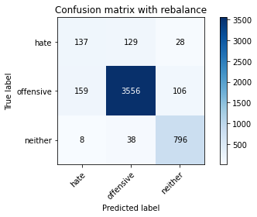

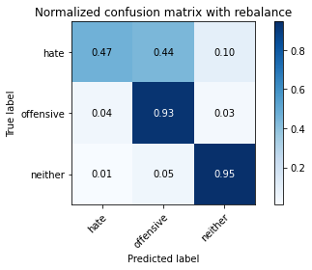

precision recall f1-score support

hate 0.45 0.47 0.46 294

offensive 0.96 0.93 0.94 3821

neither 0.86 0.95 0.90 842

accuracy 0.91 4957

macro avg 0.75 0.78 0.77 4957

weighted avg 0.91 0.91 0.91 4957

average eval_loss: 0.29901750052287696, accuracy: 0.9055880572927174

training 2 epoch...

521.6637492179871 seconds used......

2 training finished! average train loss: 0.25305191331708266

evaluating...

Confusion matrix, without normalization

[[ 155 119 20]

[ 172 3575 74]

[ 21 60 761]]

Normalized confusion matrix

[[0.52721088 0.4047619 0.06802721]

[0.04501439 0.93561895 0.01936666]

[0.02494062 0.07125891 0.90380048]]

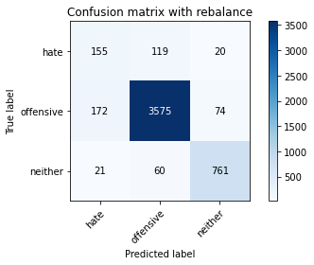

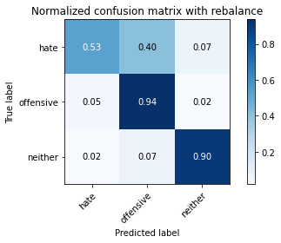

precision recall f1-score support

hate 0.45 0.53 0.48 294

offensive 0.95 0.94 0.94 3821

neither 0.89 0.90 0.90 842

accuracy 0.91 4957

macro avg 0.76 0.79 0.77 4957

weighted avg 0.91 0.91 0.91 4957

average eval_loss: 0.30877916540409767, accuracy: 0.9059915271333467

training 3 epoch...

521.8864011764526 seconds used......

3 training finished! average train loss: 0.17997048671273777

evaluating...

Confusion matrix, without normalization

[[ 123 150 21]

[ 107 3638 76]

[ 16 70 756]]

Normalized confusion matrix

[[0.41836735 0.51020408 0.07142857]

[0.02800314 0.95210678 0.01989008]

[0.01900238 0.08313539 0.89786223]]

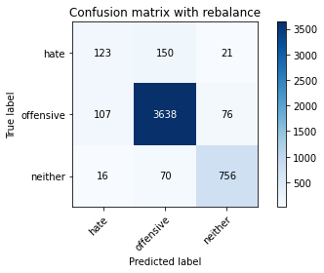

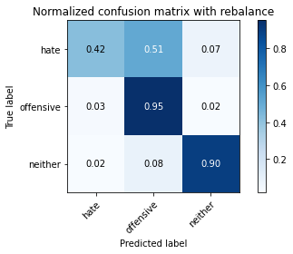

precision recall f1-score support

hate 0.50 0.42 0.46 294

offensive 0.94 0.95 0.95 3821

neither 0.89 0.90 0.89 842

accuracy 0.91 4957

macro avg 0.78 0.76 0.77 4957

weighted avg 0.91 0.91 0.91 4957

average eval_loss: 0.3433468318037358, accuracy: 0.9112366350615292

training 4 epoch...

522.1525616645813 seconds used......

4 training finished! average train loss: 0.11067610047100443

evaluating...

Confusion matrix, without normalization

[[ 72 199 23]

[ 59 3671 91]

[ 8 63 771]]

Normalized confusion matrix

[[0.24489796 0.67687075 0.07823129]

[0.01544098 0.96074326 0.02381576]

[0.00950119 0.07482185 0.91567696]]

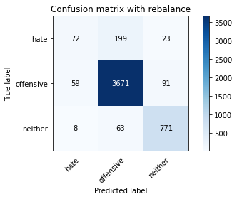

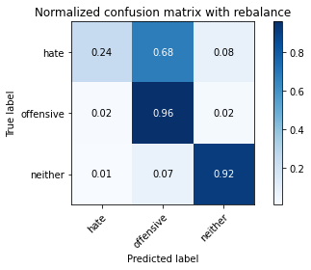

precision recall f1-score support

hate 0.52 0.24 0.33 294

offensive 0.93 0.96 0.95 3821

neither 0.87 0.92 0.89 842

accuracy 0.91 4957

macro avg 0.77 0.71 0.72 4957

weighted avg 0.90 0.91 0.90 4957

average eval_loss: 0.4535278561412387, accuracy: 0.910631430300585

training 5 epoch...

522.2806749343872 seconds used......

5 training finished! average train loss: 0.06178490244392085

evaluating...

Confusion matrix, without normalization

[[ 122 153 19]

[ 171 3575 75]

[ 24 64 754]]

Normalized confusion matrix

[[0.41496599 0.52040816 0.06462585]

[0.04475268 0.93561895 0.01962837]

[0.02850356 0.0760095 0.89548694]]

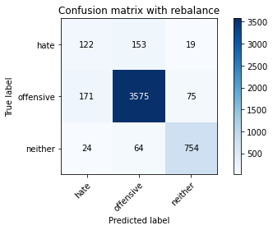

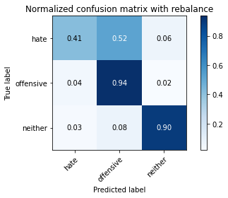

precision recall f1-score support

hate 0.38 0.41 0.40 294

offensive 0.94 0.94 0.94 3821

neither 0.89 0.90 0.89 842

accuracy 0.90 4957

macro avg 0.74 0.75 0.74 4957

weighted avg 0.90 0.90 0.90 4957

average eval_loss: 0.5318525710645777, accuracy: 0.8979221303207585

2 run......

training 1 epoch...

522.3321914672852 seconds used......

1 training finished! average train loss: 0.3563779589490995

evaluating...

Confusion matrix, without normalization

[[ 99 175 20]

[ 82 3652 87]

[ 11 65 766]]

Normalized confusion matrix

[[0.33673469 0.5952381 0.06802721]

[0.02146035 0.95577074 0.02276891]

[0.01306413 0.07719715 0.90973872]]

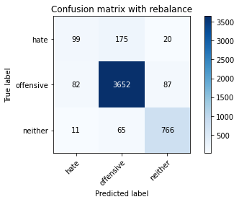

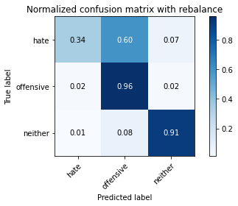

precision recall f1-score support

hate 0.52 0.34 0.41 294

offensive 0.94 0.96 0.95 3821

neither 0.88 0.91 0.89 842

accuracy 0.91 4957

macro avg 0.78 0.73 0.75 4957

weighted avg 0.90 0.91 0.91 4957

average eval_loss: 0.3185683403825087, accuracy: 0.9112366350615292

training 2 epoch...

522.3138444423676 seconds used......

2 training finished! average train loss: 0.2565525060091468

evaluating...

Confusion matrix, without normalization

[[ 136 139 19]

[ 110 3610 101]

[ 14 58 770]]

Normalized confusion matrix

[[0.46258503 0.47278912 0.06462585]

[0.02878828 0.94477885 0.02643287]

[0.01662708 0.06888361 0.91448931]]

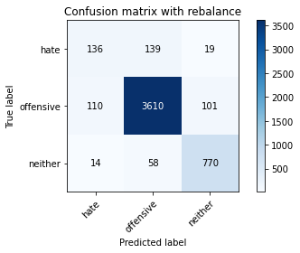

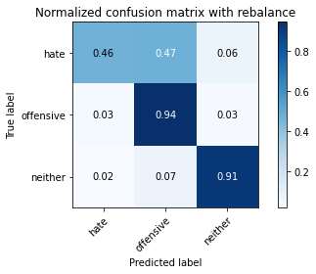

precision recall f1-score support

hate 0.52 0.46 0.49 294

offensive 0.95 0.94 0.95 3821

neither 0.87 0.91 0.89 842

accuracy 0.91 4957

macro avg 0.78 0.77 0.78 4957

weighted avg 0.91 0.91 0.91 4957

average eval_loss: 0.29832088139899554, accuracy: 0.9110349001412145

training 3 epoch...

521.9904186725616 seconds used......

3 training finished! average train loss: 0.17978609438831616

evaluating...

Confusion matrix, without normalization

[[ 128 146 20]

[ 109 3630 82]

[ 11 65 766]]

Normalized confusion matrix

[[0.43537415 0.49659864 0.06802721]

[0.02852656 0.95001309 0.02146035]

[0.01306413 0.07719715 0.90973872]]

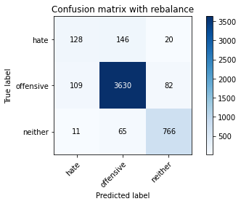

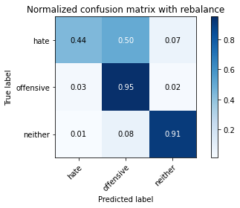

precision recall f1-score support

hate 0.52 0.44 0.47 294

offensive 0.95 0.95 0.95 3821

neither 0.88 0.91 0.90 842

accuracy 0.91 4957

macro avg 0.78 0.77 0.77 4957

weighted avg 0.91 0.91 0.91 4957

average eval_loss: 0.31160247932007956, accuracy: 0.9126487795037321

training 4 epoch...

521.4771299362183 seconds used......

4 training finished! average train loss: 0.10519589035832341

evaluating...

Confusion matrix, without normalization

[[ 106 177 11]

[ 79 3694 48]

[ 19 138 685]]

Normalized confusion matrix

[[0.36054422 0.60204082 0.03741497]

[0.02067522 0.96676263 0.01256216]

[0.02256532 0.16389549 0.81353919]]

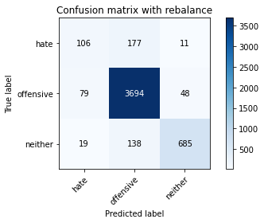

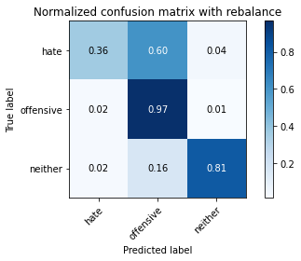

precision recall f1-score support

hate 0.52 0.36 0.43 294

offensive 0.92 0.97 0.94 3821

neither 0.92 0.81 0.86 842

accuracy 0.90 4957

macro avg 0.79 0.71 0.74 4957

weighted avg 0.90 0.90 0.90 4957

average eval_loss: 0.4985898524135982, accuracy: 0.9047811176114585

training 5 epoch...

522.0538952350616 seconds used......

5 training finished! average train loss: 0.056718545419273375

evaluating...

Confusion matrix, without normalization

[[ 144 138 12]

[ 228 3522 71]

[ 31 85 726]]

Normalized confusion matrix

[[0.48979592 0.46938776 0.04081633]

[0.05967024 0.92174823 0.01858152]

[0.0368171 0.10095012 0.86223278]]

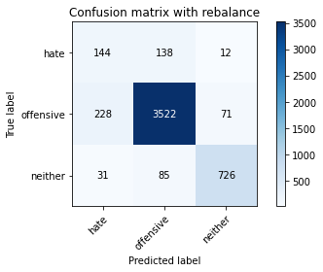

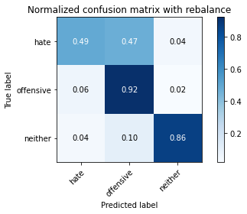

precision recall f1-score support

hate 0.36 0.49 0.41 294

offensive 0.94 0.92 0.93 3821

neither 0.90 0.86 0.88 842

accuracy 0.89 4957

macro avg 0.73 0.76 0.74 4957

weighted avg 0.90 0.89 0.89 4957

average eval_loss: 0.5159311094279063, accuracy: 0.8860197700221908

3 run......

training 1 epoch...

521.8518583774567 seconds used......

1 training finished! average train loss: 0.3604659405461843

evaluating...

Confusion matrix, without normalization

[[ 106 167 21]

[ 100 3623 98]

[ 16 44 782]]

Normalized confusion matrix

[[0.36054422 0.56802721 0.07142857]

[0.02617116 0.9481811 0.02564774]

[0.01900238 0.05225653 0.92874109]]

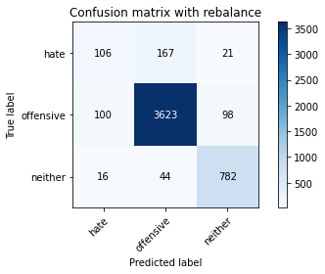

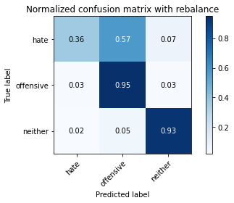

precision recall f1-score support

hate 0.48 0.36 0.41 294

offensive 0.94 0.95 0.95 3821

neither 0.87 0.93 0.90 842

accuracy 0.91 4957

macro avg 0.76 0.75 0.75 4957

weighted avg 0.90 0.91 0.91 4957

average eval_loss: 0.3107655236737863, accuracy: 0.910026225539641

training 2 epoch...

521.3942766189575 seconds used......

2 training finished! average train loss: 0.25576510462692126

evaluating...

Confusion matrix, without normalization

[[ 177 96 21]

[ 218 3504 99]

[ 22 26 794]]

Normalized confusion matrix

[[0.60204082 0.32653061 0.07142857]

[0.05705313 0.91703742 0.02590945]

[0.02612827 0.03087886 0.94299287]]

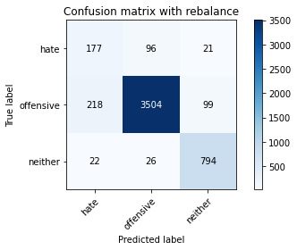

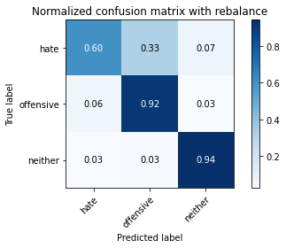

precision recall f1-score support

hate 0.42 0.60 0.50 294

offensive 0.97 0.92 0.94 3821

neither 0.87 0.94 0.90 842

accuracy 0.90 4957

macro avg 0.75 0.82 0.78 4957

weighted avg 0.92 0.90 0.91 4957

average eval_loss: 0.30344542240603795, accuracy: 0.9027637684083115

training 3 epoch...

521.5904984474182 seconds used......

3 training finished! average train loss: 0.18168404400902574

evaluating...

Confusion matrix, without normalization

[[ 143 128 23]

[ 145 3560 116]

[ 16 30 796]]

Normalized confusion matrix

[[0.48639456 0.43537415 0.07823129]

[0.03794818 0.93169327 0.03035854]

[0.01900238 0.03562945 0.94536817]]

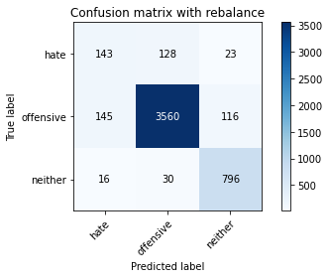

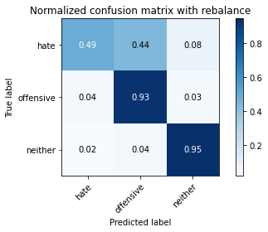

precision recall f1-score support

hate 0.47 0.49 0.48 294

offensive 0.96 0.93 0.94 3821

neither 0.85 0.95 0.90 842

accuracy 0.91 4957

macro avg 0.76 0.79 0.77 4957

weighted avg 0.91 0.91 0.91 4957

average eval_loss: 0.33103243992363496, accuracy: 0.9076054064958644

training 4 epoch...

521.7991297245026 seconds used......

4 training finished! average train loss: 0.11102497133599114

evaluating...

Confusion matrix, without normalization

[[ 87 181 26]

[ 85 3637 99]

[ 11 54 777]]

Normalized confusion matrix

[[0.29591837 0.61564626 0.08843537]

[0.02224549 0.95184507 0.02590945]

[0.01306413 0.06413302 0.92280285]]

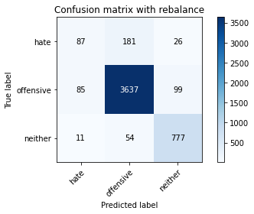

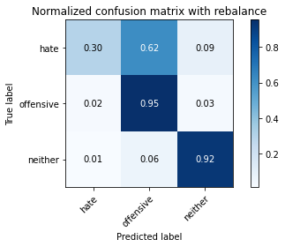

precision recall f1-score support

hate 0.48 0.30 0.36 294

offensive 0.94 0.95 0.95 3821

neither 0.86 0.92 0.89 842

accuracy 0.91 4957

macro avg 0.76 0.72 0.73 4957

weighted avg 0.90 0.91 0.90 4957

average eval_loss: 0.4429186342702803, accuracy: 0.9080088763364939

training 5 epoch...

521.5872890949249 seconds used......

5 training finished! average train loss: 0.057316282648072606

evaluating...

Confusion matrix, without normalization

[[ 145 132 17]

[ 240 3508 73]

[ 22 85 735]]

Normalized confusion matrix

[[0.49319728 0.44897959 0.05782313]

[0.06281078 0.91808427 0.01910495]

[0.02612827 0.10095012 0.87292162]]

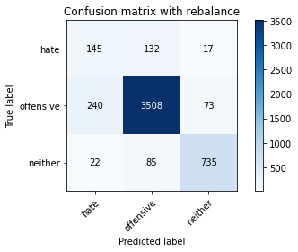

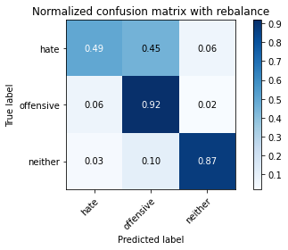

precision recall f1-score support

hate 0.36 0.49 0.41 294

offensive 0.94 0.92 0.93 3821

neither 0.89 0.87 0.88 842

accuracy 0.89 4957

macro avg 0.73 0.76 0.74 4957

weighted avg 0.90 0.89 0.89 4957

average eval_loss: 0.5194820190344246, accuracy: 0.885212830340932

4 run......

training 1 epoch...

521.0645277500153 seconds used......

1 training finished! average train loss: 0.3606066219151891

evaluating...

Confusion matrix, without normalization

[[ 154 106 34]

[ 162 3523 136]

[ 11 20 811]]

Normalized confusion matrix

[[0.52380952 0.36054422 0.11564626]

[0.04239728 0.92200995 0.03559278]

[0.01306413 0.02375297 0.9631829 ]]

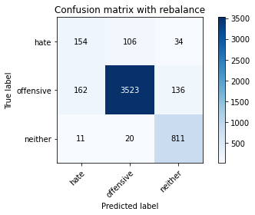

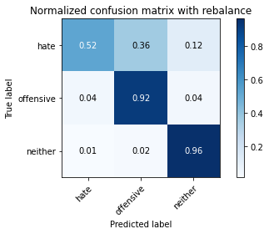

precision recall f1-score support

hate 0.47 0.52 0.50 294

offensive 0.97 0.92 0.94 3821

neither 0.83 0.96 0.89 842

accuracy 0.91 4957

macro avg 0.75 0.80 0.78 4957

weighted avg 0.91 0.91 0.91 4957

average eval_loss: 0.3028903768713316, accuracy: 0.9053863223724027

training 2 epoch...

521.1824061870575 seconds used......

2 training finished! average train loss: 0.2545103785946154

evaluating...

Confusion matrix, without normalization

[[ 79 192 23]

[ 47 3689 85]

[ 4 67 771]]

Normalized confusion matrix

[[0.26870748 0.65306122 0.07823129]

[0.01230044 0.96545407 0.02224549]

[0.00475059 0.07957245 0.91567696]]

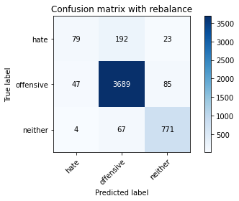

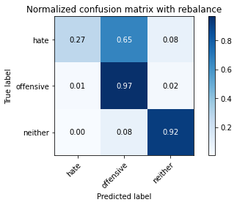

precision recall f1-score support

hate 0.61 0.27 0.37 294

offensive 0.93 0.97 0.95 3821

neither 0.88 0.92 0.90 842

accuracy 0.92 4957

macro avg 0.81 0.72 0.74 4957

weighted avg 0.91 0.92 0.91 4957

average eval_loss: 0.3178286736252748, accuracy: 0.9156748033084527

training 3 epoch...

521.1309430599213 seconds used......

3 training finished! average train loss: 0.179343520549141

evaluating...

Confusion matrix, without normalization

[[ 142 136 16]

[ 153 3595 73]

[ 27 61 754]]

Normalized confusion matrix

[[0.4829932 0.46258503 0.05442177]

[0.04004187 0.94085318 0.01910495]

[0.03206651 0.07244656 0.89548694]]

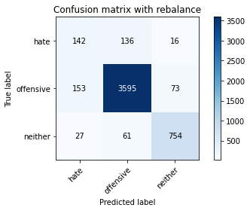

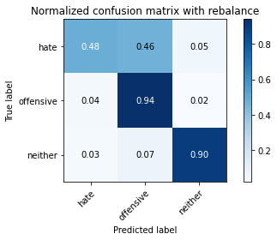

precision recall f1-score support

hate 0.44 0.48 0.46 294

offensive 0.95 0.94 0.94 3821

neither 0.89 0.90 0.89 842

accuracy 0.91 4957

macro avg 0.76 0.77 0.77 4957

weighted avg 0.91 0.91 0.91 4957

average eval_loss: 0.3470834356022909, accuracy: 0.9059915271333467

training 4 epoch...

522.1926953792572 seconds used......

4 training finished! average train loss: 0.11248476555485995

evaluating...

Confusion matrix, without normalization

[[ 163 112 19]

[ 210 3540 71]

[ 23 68 751]]

Normalized confusion matrix

[[0.55442177 0.38095238 0.06462585]

[0.05495943 0.92645904 0.01858152]

[0.02731591 0.0807601 0.89192399]]

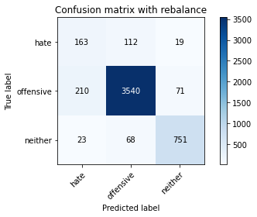

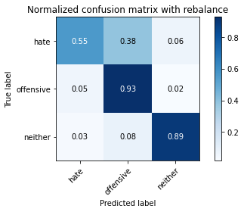

precision recall f1-score support

hate 0.41 0.55 0.47 294

offensive 0.95 0.93 0.94 3821

neither 0.89 0.89 0.89 842

accuracy 0.90 4957

macro avg 0.75 0.79 0.77 4957

weighted avg 0.91 0.90 0.90 4957

average eval_loss: 0.44973739347563335, accuracy: 0.8985273350817027

training 5 epoch...

522.7586798667908 seconds used......

5 training finished! average train loss: 0.06308093231323696

evaluating...

Confusion matrix, without normalization

[[ 156 119 19]

[ 232 3517 72]

[ 38 64 740]]

Normalized confusion matrix

[[0.53061224 0.4047619 0.06462585]

[0.06071709 0.92043968 0.01884323]

[0.04513064 0.0760095 0.87885986]]

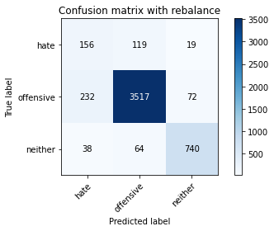

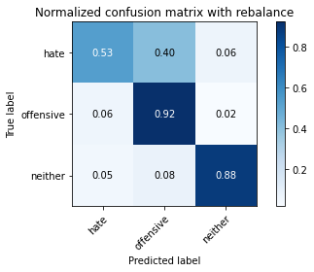

precision recall f1-score support

hate 0.37 0.53 0.43 294

offensive 0.95 0.92 0.94 3821

neither 0.89 0.88 0.88 842

accuracy 0.89 4957

macro avg 0.74 0.78 0.75 4957

weighted avg 0.91 0.89 0.90 4957

average eval_loss: 0.5491905136765244, accuracy: 0.8902562033487996

5 run......

training 1 epoch...

522.2682456970215 seconds used......

1 training finished! average train loss: 0.35234748727206383

evaluating...

Confusion matrix, without normalization

[[ 122 134 38]

[ 114 3584 123]

[ 7 27 808]]

Normalized confusion matrix

[[0.41496599 0.45578231 0.1292517 ]

[0.02983512 0.93797435 0.03219053]

[0.00831354 0.03206651 0.95961995]]

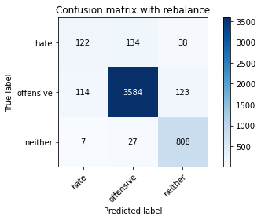

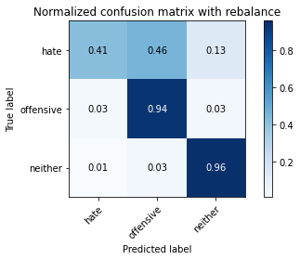

precision recall f1-score support

hate 0.50 0.41 0.45 294

offensive 0.96 0.94 0.95 3821

neither 0.83 0.96 0.89 842

accuracy 0.91 4957

macro avg 0.76 0.77 0.76 4957

weighted avg 0.91 0.91 0.91 4957

average eval_loss: 0.30675396985644776, accuracy: 0.910631430300585

training 2 epoch...

522.8128588199615 seconds used......

2 training finished! average train loss: 0.2537814938433228

evaluating...

Confusion matrix, without normalization

[[ 139 126 29]

[ 133 3581 107]

[ 12 39 791]]

Normalized confusion matrix

[[0.47278912 0.42857143 0.09863946]

[0.03480764 0.93718922 0.02800314]

[0.01425178 0.04631829 0.93942993]]

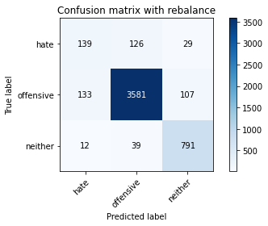

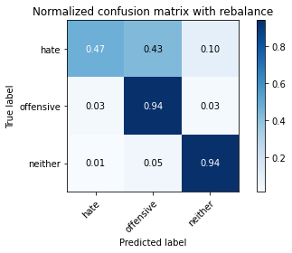

precision recall f1-score support

hate 0.49 0.47 0.48 294

offensive 0.96 0.94 0.95 3821

neither 0.85 0.94 0.89 842

accuracy 0.91 4957

macro avg 0.77 0.78 0.77 4957

weighted avg 0.91 0.91 0.91 4957

average eval_loss: 0.2986918702916873, accuracy: 0.910026225539641

training 3 epoch...

522.1275494098663 seconds used......

3 training finished! average train loss: 0.1758243624961676

evaluating...

Confusion matrix, without normalization

[[ 123 141 30]

[ 103 3603 115]

[ 9 30 803]]

Normalized confusion matrix

[[0.41836735 0.47959184 0.10204082]

[0.02695629 0.94294687 0.03009683]

[0.01068884 0.03562945 0.95368171]]

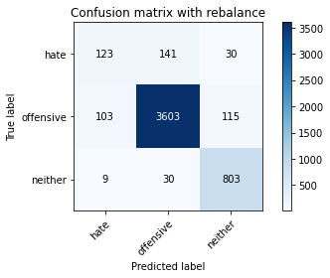

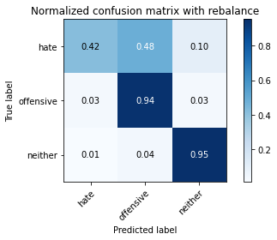

precision recall f1-score support

hate 0.52 0.42 0.47 294

offensive 0.95 0.94 0.95 3821

neither 0.85 0.95 0.90 842

accuracy 0.91 4957

macro avg 0.78 0.77 0.77 4957

weighted avg 0.91 0.91 0.91 4957

average eval_loss: 0.40196713508011006, accuracy: 0.9136574541053056

training 4 epoch...

521.8016519546509 seconds used......

4 training finished! average train loss: 0.10232167471223229

evaluating...

Confusion matrix, without normalization

[[ 101 179 14]

[ 97 3658 66]

[ 15 87 740]]

Normalized confusion matrix

[[0.34353741 0.60884354 0.04761905]

[0.02538602 0.95734101 0.01727297]

[0.01781473 0.10332542 0.87885986]]

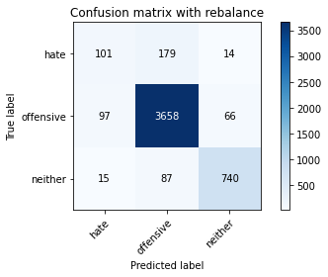

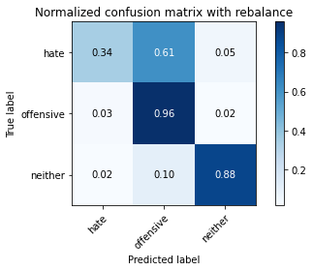

precision recall f1-score support

hate 0.47 0.34 0.40 294

offensive 0.93 0.96 0.94 3821

neither 0.90 0.88 0.89 842

accuracy 0.91 4957

macro avg 0.77 0.73 0.74 4957

weighted avg 0.90 0.91 0.90 4957

average eval_loss: 0.4450643181241298, accuracy: 0.9076054064958644

training 5 epoch...

522.2475636005402 seconds used......

5 training finished! average train loss: 0.05703404631632962

evaluating...

Confusion matrix, without normalization

[[ 115 154 25]

[ 154 3558 109]

[ 16 53 773]]

Normalized confusion matrix

[[0.39115646 0.52380952 0.08503401]

[0.04030359 0.93116985 0.02852656]

[0.01900238 0.06294537 0.91805226]]

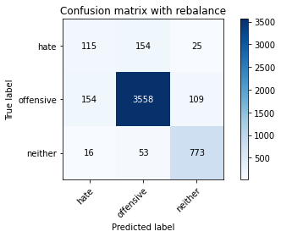

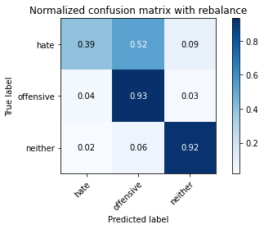

precision recall f1-score support

hate 0.40 0.39 0.40 294

offensive 0.95 0.93 0.94 3821

neither 0.85 0.92 0.88 842

accuracy 0.90 4957

macro avg 0.73 0.75 0.74 4957

weighted avg 0.90 0.90 0.90 4957

average eval_loss: 0.5377825143710769, accuracy: 0.896913455719185